Table Of Contents
ABSTRACT 3
METHODOLOGY 3
COMMUNITY CONSULTATIONS 3
SITE VISITATION AND OBSERVATION 3
INTRODUCTION 4
STATEMENT OF THE PROBLEM 4
IMPLICATIONS AND CONSEQUENCES 4
ADVANTAGES 4
SOCIAL AND ECONOMIC BENEFITS 4
DISADVANTAGES 4
POTENTIAL IMPACT ON COMMUNITY HEALTH 4
ENVIRONMENTAL CONSIDERATION 5
PROPOSAL PLAN AND SCHEDULE 5
REVIEW OF BEST PRACTICES 5
EQUIPMENTS 6
PROCEDURES 6
COSTS 6
SCHEDULED TIME 6
PERSONNEL 7
RECOMMENDATIONS 7

LIST OF FIGURES
Figure 1.2: source of water 2

Table 1 5
Table 2 5

ABSTRACT
Based on our group's research, we discovered that there is a water problem that is being experienced in Chinganganga village. The outcomes of this water issue include waterborne diseases such as cholera, dysentery, and typhoid fever. long distances are another problem, whereby villagers walk long distances to reach their water source. Some of the solutions to this water problem are rainwater harvesting, construction of boreholes and water kiosk, education and awareness programs, and the use of chemical disinfection. If this problem can be solved, it can positively affect Chinganganga village in several ways. For instance, borehole and water kiosk can be done in different places in this village, whereby people will not walk long distances fetching water. The purpose of this proposal is to ask the Water AID organization to consider our suggested solutions to the problem that the Chinganganga people are facing.

METHODOLOGY
To ensure that the proposed solution is both effective and sustainable we used an approach to addressing the water problems faced by people in Chinganganga village involving the following:

COMMUNITY CONSULTATIONS
Consultations were held with stakeholders in the village including the village chief and residents based on the problems they usually face or the problems that affect the community. It was found that most residents had a problem with proper water sources. These consultations revealed high contamination issues and a strong desire for clean water. The contamination of the water however puts the village at high risk of waterborne diseases such as cholera, particularly affecting children under the age of five (Munthali, 2020).

SITE VISITATION AND OBSERVATION
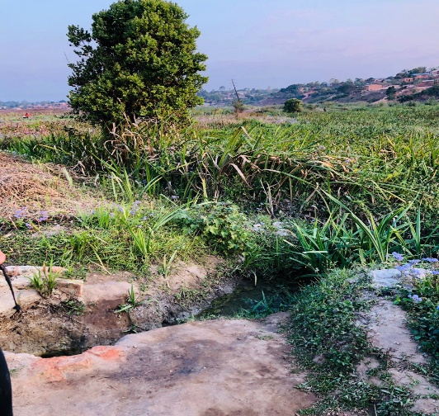
We also conducted a site visit to the current source of water to assess the condition. The visit revealed that the wells were not only unprotected but also contaminated by runoff water since the place is located steep slope.

Figure 1.2: source of water
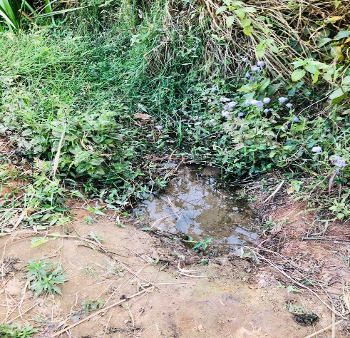
Figure 1.1: source of water

INTRODUCTION
According to Rompel (2020), Malawi is one of the world's poorest countries and faces numerous development challenges including limited access to clean water, sanitation, and hygiene abbreviated as WASH, which is affecting people negatively. In Mzuzu, Chinganganga village struggles with inadequate access to clean water, relying on contaminated shallow wells and springs which Is increasing the risk of water-borne diseases like cholera, diarrhea, and typhoid thereby forcing individuals to travel long distances to fetch clean water,

STATEMENT OF THE PROBLEM
The community has a big problem, not enough Clean water. Many people do not have access to clean water for drinking and washing. Instead, they use contaminated water from wells and seasoned streams. Using dirty water can cause stomach pain, diarrhea and even serious diseases like cholera. This affects not only their health but also their daily lives. They cannot work or go to school because they are sick or need to spend time finding clean water. This also affects their family’s income and food, making life even harder. We want to help overcome or fix this problem and find a way to get clean water to everyone in the community.

IMPLICATIONS AND CONSEQUENCES

ADVANTAGES

SOCIAL AND ECONOMIC BENEFITS
On the other hand, a sustainable water supply system can bring numerous benefits. Access to clean water will enable the community to produce more crops during harvesting, as they will have the capacity to farm during the rainy season, leading to improved food security and economic growth (Economic Benefits of Improved Water Supply in Malawi, 2013). This, in turn, will improve the community's livelihoods and reduce poverty. Moreover, a reliable water supply will reduce the risk of water-borne diseases, promoting a healthier community and reducing medical costs (Impact of Water Supply on Women's Empowerment in Rural Malawi, 2015). Proper wastewater management will also prevent pollution and protect aquatic ecosystems, ensuring a sustainable future for the village (The Impact of Water Infrastructure on Economic Growth in Malawi, 2020).

DISADVANTAGES

POTENTIAL IMPACT ON COMMUNITY HEALTH
The inadequate water supply in Chinganganga Village poses significant health risks to the community, particularly the threat of cholera outbreaks due to unhealthy water (Cholera Outbreaks in Malawi, 2018). This can lead to a decline in education status as children fall ill and fail to attend school, ultimately affecting the community's human capital development (Water, Sanitation, and Hygiene and Poverty Reduction in Malawi, 2017). Furthermore, the unhygienic water drawn from dams can cause skin infections due to the presence of bacteria and viruses, leading to increased medical costs and reduced productivity (Assessing the Burden of Cholera in Malawi, 2019). The community's overall well-being will suffer as illness hinders their ability to support one another.

ENVIRONMENTAL CONSIDERATION
Water is an essential input for agricultural production because different crops require different amounts of water for optional growth. Agriculture also plays a major role in the water equation because it accounts for about 70% of freshwater withdrawals. Water scarcity means less water available for agricultural production, which puts food security and nutrition at risk. Given that the world's population is expected to reach 9 billion people by the year 2050, it is evident that water scarcity poses a real threat to food security because more food will need to be grown with limited water resources. In a situation where water has become scarce, different groups mainly communities compete for the limited supply. This competition can escalate into conflicts over resources, especially in areas like Chinganganga where water is essential for agriculture and daily living (Wolf, 2007). There is also a possibility that conflicts can arise in Chinganganga whereby the communities can develop conflict over the control and management of water infrastructures like wells.

PROPOSAL PLAN AND SCHEDULE
According to the problems faced by Chinganganga village, there was a list of suggestions that would help the village overcome the challenges that they are facing. Here are some of how the problems can resolved:

REVIEW OF BEST PRACTICES
We reviewed successful water projects in Malawi, such as those implemented in other rural areas which improved access to clean water. These projects involve the construction of boreholes, pump aids, and tap water that emphasize protection and community involvement in both construction and maintenance (Chavula, 2019). Such implementations were made by the Titukulane where they handed over 180 boreholes in Mangochi and Zomba.
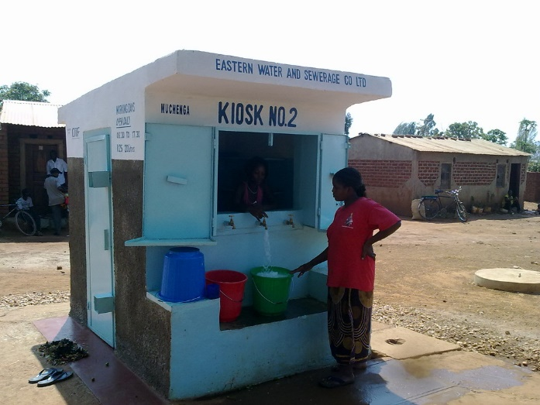
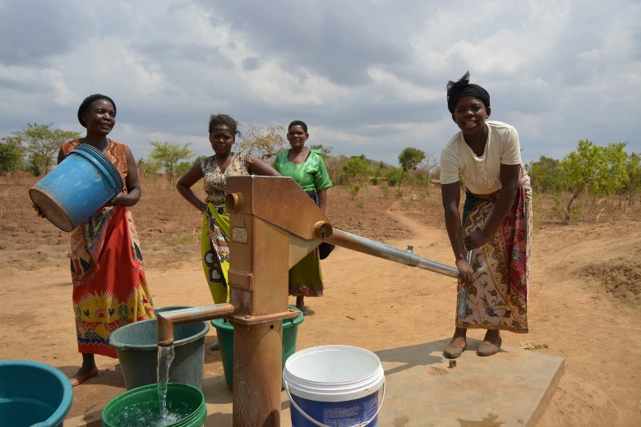
Figure 2.1 Water Kiosks
Figure 2.2 Boreholes

EQUIPMENTS
      - Boreholes
      - Kiosks
      - Drums

PROCEDURES
The shortage of water will be reduced in the community by planting Boreholes. This is of use in the dry season when wells dry up. This activity can be done by BLUE WATER DRILLING LTD which is the trusted company in Malawi for drilling boreholes. Drilling boreholes will also help shorten the distance from the village's water source to their settlements.
Secondly, building kiosks can also help supply clean water since it is treated and supplied to the people because it is tapped. This will help prevent the waterborne diseases that arise. an example is The E-Madzi system project which was carried out in Lilongwe.
Water harvesting techniques can also be implemented to help them have sustainable water sources for instant use. This will require drums for the collection and safekeeping of water.
Lastly, there will also be a need for education and awareness programs. This will help them have an insight into the goodness of clean water and how to take care of it to avoid waterborne diseases. This will also tackle how to treat water for example through boiling or chemical treatment.

COSTS
Table 1
EQUIPMENT | COSTS
4 BOREHOLES | 4 * MK5,000,000 = MK20,000,000
1 KIOSK | MK2,000,000
1000 DRUMS | 1000*K45,000 = MK45,000,000

SCHEDULED TIME
This operation should be carried out as soon as all the required equipment is gathered together. This is how the project will go about.
Table 2
DAY | TIME
MONDAY | 8 AM-4 PM
TUESDAY | 8 AM-4 PM
WEDNESDAY | 8 AM-4 PM
THURSDAY | 8 AM-4 PM
FRIDAY | 8 AM-4 PM
This project will be carried out for at most a month for the villagers to have access to all the needed supplies.

PERSONNEL
This will require people who are qualified for public health, and skilled laborers that build any structures that are needed. Concerning the Boreholes, the BLUE WATER DRILLING LTD will deal with any operations that will be needed. there will also be a need of hiring people that will construct the kiosks.

RECOMMENDATIONS
In the essence of effectively addressing the critical need for clean and sustainable water in the village, we strongly recommend forming a partnership with your organization as it is special in water management and community development. Engaging with the organization will provide us with the expertise and resources necessary to implement successful solutions. With this workforce, we can establish reliable sources of clean water, educate the community on hygiene practices, and empower residents to maintain the water systems00. This collaboration will not only improve the health and well-being of the villagers but also create a lasting impact on the community`s future. We believe that together, we can make a significant difference in this area's lives.

REFERENCES
Assessing the Burden of Cholera in Malawi (2019). World Health Organization.
Cholera Outbreaks in Malawi: A Review of the Literature (2018). Malawi Medical Journal.
Economic Benefits of Improved Water Supply in Malawi (2013). Water and Sanitation Program, World Bank.
Impact of Water Supply on Women's Empowerment in Rural Malawi (2015). Journal of Water, Sanitation and Hygiene for Development.
The Impact of Water Infrastructure on Economic Growth in Malawi (2020). Malawi National Statistical Office.
Water, Sanitation, and Hygiene and Poverty Reduction in Malawi (2017). UNICEF Malawi.
Wolf,A.T.(2007). Shared waters, shared benefits: Lessons from the Himalayas.Journal of contemporary water research and Education.(14-26).
Rompel, M. (2020). Malawi Five Decades after Independence: Failed State or Latecomer. Malawi: Economy, Society and Political Affairs. London: Zed, 11-30.

References
Munthali, A. C. (2022). Health impacts of water, sanitation, and hygiene in Malawi: A case study of cholera outbreaks in Mzuzu city. Malawi Medical Journal, 34(2), 102-110.
Chavula, G. (2019). Water resources management challenges in southern Africa: Malawi’s case. In B. Van Koppen, M. Giordano, & J. Butterworth (Eds.), Community-based water law and water resource management reform in developing countries (pp. 123-137). CABI Publishing.

